Operations/Work/Job Activity covered by this assessment: Mounting Machine
Required Personal Protective Equipment (PPE) :

Safety glasses must be worn at times. |   Long and loose hair must be contained.
  Appropriate footwear with substantial uppers must be worn. |   Close fitting/protective clothing to cover arms and legs must be worn.
Respiratory protection devices required. |   Oil free leather gloves and spats must be worn.

Hearing protection must be used when using this machine.

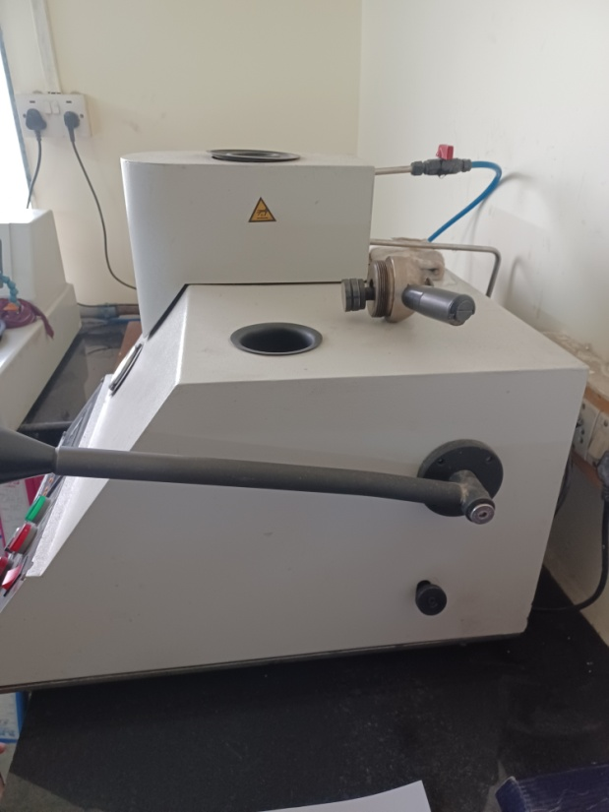
A
B
D
C
I
- Switch ON the power (A)

- Check the waterline to ensure constant flow of
water and lock the same. (B)

- By operating the right hand side lever (C) move
the spindle UP and open the lid in the mounting
machine (D)

- Apply the WD 40 spray(aerosol) on the inner surface of
chamber and on top of the spindle (E) and on the
inner surface of the top cover (F)
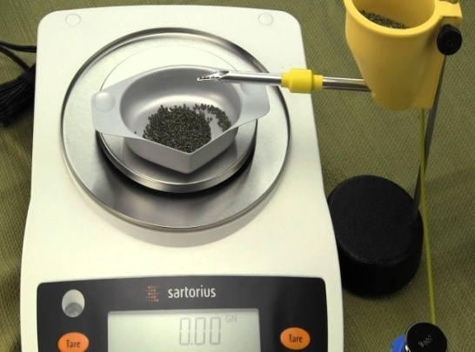
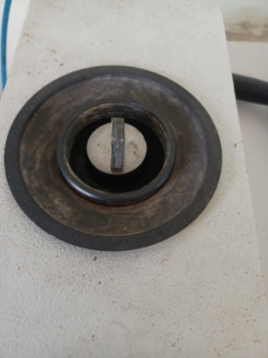
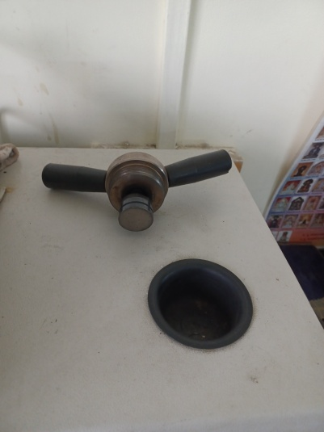
F
E
H
G
- Weigh 18.5 gms of phenolic powder for mounting
and keep it on a butter paper (G)

- Keep the specimen on top of the spindle as shown
(H) and lower the spindle by unlocking the knob
on the right hand side (I)

- Pour the powder in the chamber at centre of the
hole very slowly.

- Place the lid on the chamber and rotate it clockwise.
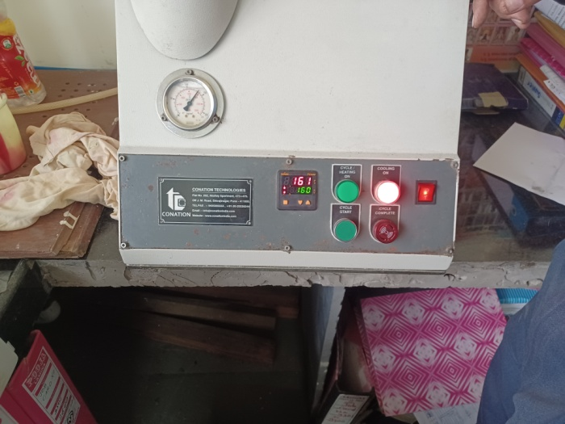
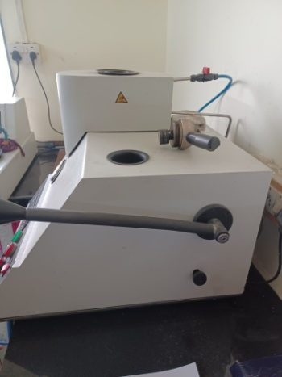
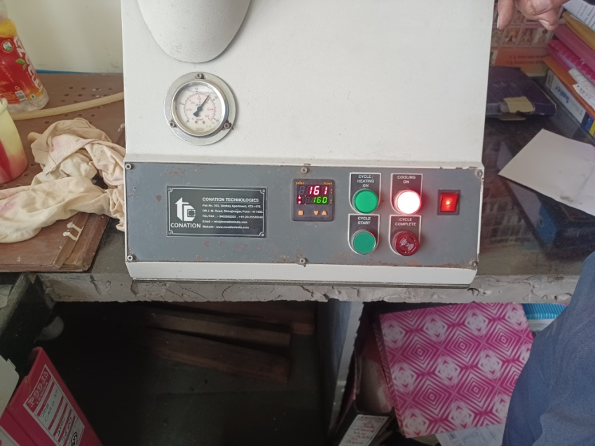
M
K
L
J
N
- After tightening the lid from the top and just release
a little by rotating anti-clockwise.

- Lock the knob (I) on the right hand side.

- Switch `ON’ the Mains situated on the backside of the
machine (J)

- Switch `ON’ Red power button (K) on the front right
hand corner

- When the display shows `Cycle complete’, switch on
`Cycle heating’ (L)

- Keep applying pressure through Right hand side lever (C)
by pressing downwards continuously till the
pressure reaches 2000 psi (M) and the temp
reaches 160⁰ C. Maintain the pressure.

- At 160^{O}C temp and 2000 psi, the heating is stopped
and the cooling process begins (N)

- Switch on the water flow to the mould by opening the
valve in the pipeline (B).

- When the temperature of the mould reaches room temp,
release the knob (I) and remove the lid (E) by rotating
anticlockwise

- Lock the Knob (I) and using the right hand side lever ©, raise the spindle up and remove the specimen.

